Predicting Depression from
Routine Household Survey Data
Can economic and household data help identify people at risk of depression in rural Kenya?
Ian Kibet Leboo | AI4EAC Health Practice Challenge | Busara Center for Behavioral Economics | Zindi Africa
1. The Problem
Kenya has one of the highest rates of untreated depression in the world. The World Health Organization estimates that 1.3 million Kenyans suffer from major depressive disorder each year, yet with only two certified psychiatrists per million people, most communities have little or no access to mental health support. The gap is widest in rural areas.
Community health workers and local clinics do reach rural communities, but their capacity is limited. They cannot visit everyone. The question this project set out to answer is:

KEY QUESTION | Can routine survey data that is already being collected for other reasons such as economic activity, food security, household assets; help identify the people most likely to be experiencing depression, so that limited health resources can be directed where they are needed most?

1.3M  Kenyans with untreated depression  WHO estimate, per year |  | 2  Psychiatrists per million people  Kenya national average |  | 1,143  Individuals in this dataset  Rural Kenya, Busara Center

2. The Data and Approach
The dataset was provided by the Busara Center for Behavioral Economics as part of the Zindi AI4EAC Health Practice Challenge. It contains survey responses from 1,143 individuals in rural Kenya, covering household economic activity, food security, asset ownership, health expenditure, education, and mobile money usage. The target variable was whether the respondent met the epidemiological threshold for moderate depression.
Who was in the data?
Out of 1,143 individuals, 193 (16.9%) were identified as depressed and 950 (83.1%) were not. This imbalance reflects real-world prevalence and made the modelling more complex since a model that simply predicts 'not depressed' for everyone would still be correct 83% of the time, which is not useful.
What did we do with the data?
- Cleaned and reduced around 75 variables down to approximately 50 meaningful features by removing survey identifiers, near-empty columns, and highly correlated duplicates.
- Used a technique called MICE (Multiple Imputation by Chained Equations) to fill in missing values in a statistically sound way rather than simply dropping incomplete records.

Table 1: Summary of data preprocessing and variable selection
Pre-processing step | Variable count
Total available variables | 75
Survey identifiers (id, village, date, day_of_week) | 4
Constant variables | 3
Redundant derived variables | 1
Categorical encoding (none recording) | 15
Categorical encoding (non required) | 0
MICE imputation (no variables dropped) | 0
Above 0.8 correlated features | 7
Total excluded | 30
Final variables | 45

- Balanced the data using SMOTE-ENN, a method that generates additional examples of the minority group (depressed individuals) during training so the model learns to detect them rather than ignoring them.
- Tested seven different machine learning models and selected XGBoost as the best performer based on its ability to correctly identify depressed individuals.

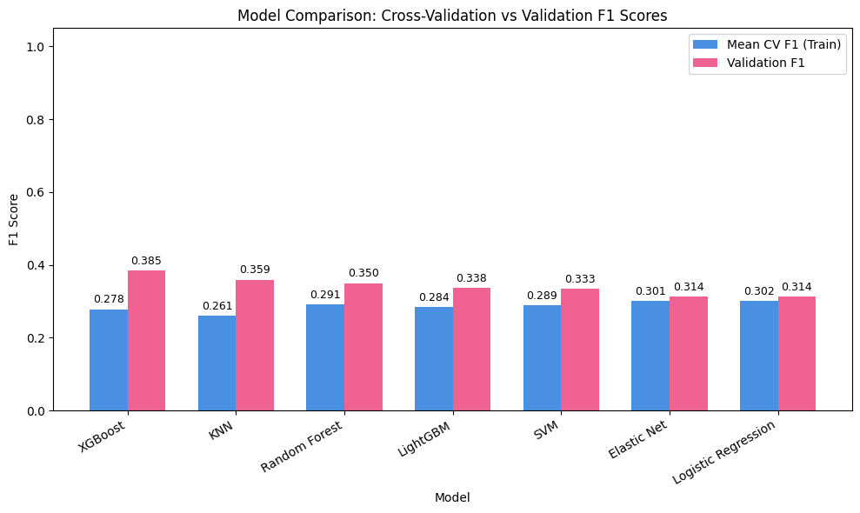
Figure 1: Model comparison: Cross-Validation vs Validation F1 Scores
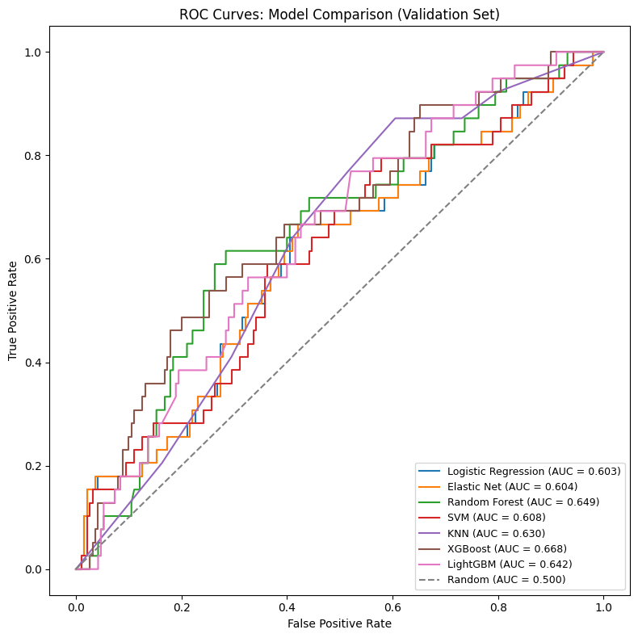
Figure 2: ROC Curves Model comparison

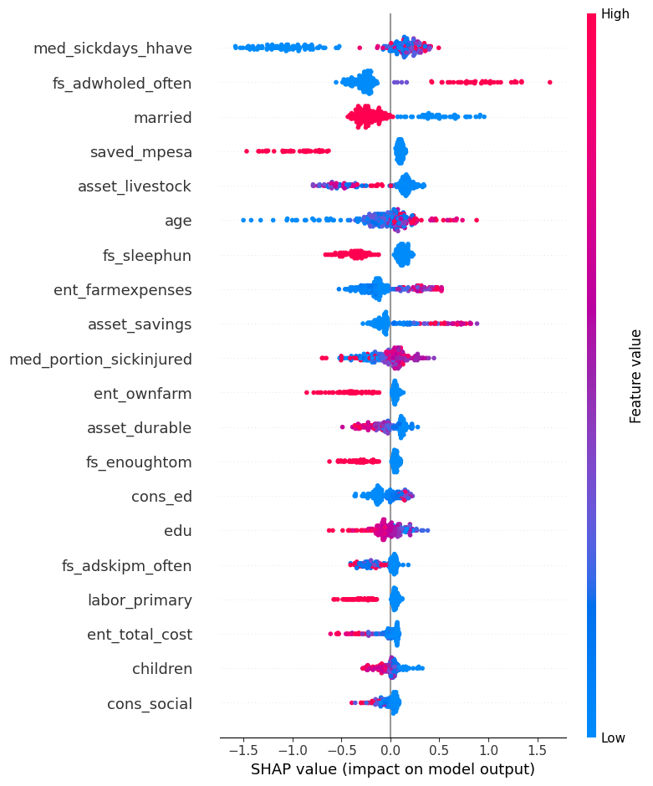
Figure 3: SHAP feature importance chart here (top 15 features)
What did the model learn?
The most influential factors for predicting depression were related to food insecurity (going without food or sleep due to hunger), household health burden (number of sick days, proportion of household members sick or injured), economic hardship (low savings, low asset ownership, limited farm income), and marital status and age. These findings are consistent with what existing mental health research tells us about the social and economic drivers of depression.

3. The Results
The table below shows how well the final model performed on a held-out group of 229 individuals it had never seen during training.

 | Precision | Recall | F1 Score | Count
Not Depressed | 0.88 | 0.71 | 0.78 | 190
Depressed | 0.26 | 0.51 | 0.35 | 39
Overall Accuracy |  |  | 67% | 229

The most important number here is Recall for the Depressed class: 0.51. This means the model correctly flagged about 1 in 2 people who were actually depressed. In a screening context, missing a true case is more costly than a false alarm that leads to a brief follow-up visit. The model is therefore most useful as a first-pass filter, not a final diagnosis.

What does this look like in practice?
The model was deployed as a simple interactive app (built with Streamlit) that a health worker or researcher can use to input survey responses for an individual and receive an estimated depression risk level (Low, Medium, or High) along with a plain-language explanation of which factors most influenced that result.

EXAMPLE | A 45-year-old woman who reports frequent food deprivation, has no household savings, and has had multiple sick household members in the past month would be flagged as High Risk and prioritised for a follow-up visit by a community health worker.

4. What This Means for Practitioners
This tool is not a replacement for a clinical screening instrument like the PHQ-9 or a trained mental health professional. It is designed to answer a narrower but very practical question: given limited time and resources, which households should a community health worker visit first?
- First point: Use as a triage aid, not a diagnosis.
- Pair with a human-in-the-loop process. Anyone flagged as high risk should receive a brief follow-up conversation or validated screening, not direct intervention based on the model alone.
- Plan for false positives. Roughly 3 in 4 individuals flagged as high risk will not meet the depression threshold. Field teams should be briefed on this so trust in the tool is maintained.
- Re-validate before scaling. The model was trained on data from specific rural communities in Kenya. Economic conditions and their relationship to depression may vary across regions and should be re-tested before wider rollout.
5. Limitations and Next Steps
The model's F1 score for the depressed class (0.35) reflects a genuinely hard problem: detecting depression from indirect economic and behavioural proxies without any direct psychosocial indicators. This is an honest limitation, not a failure of the approach.
What could improve this in the future?
- Adding direct psychosocial indicators such as social support scores, recent life events, or sleep quality measures.
- Using larger, pooled datasets from multiple regions to improve model generalisation.
- Optimising the decision threshold based on the actual cost of false positives versus false negatives in a specific programme context.
- Longitudinal data that captures how circumstances change over time would allow the model to detect deterioration rather than just current state.

Data: Busara Center for Behavioral Economics via Zindi Africa (AI4EAC Health Practice Challenge). In partnership with AI Kenya, Women in Machine Learning and Data Science, Tulaa, and ALX Launchpad.

